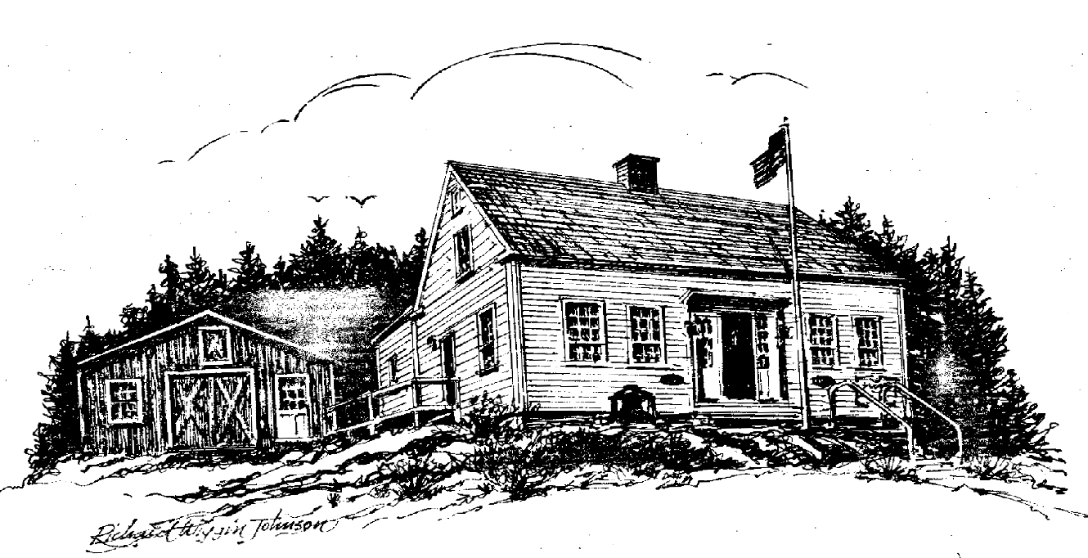
Friends of the Southport Historical Society

P. O. Box 3, Southport, ME 04576

HENDRICKS HILL MUSEUM

Newsletter ***** November 2015

Donald Duncan, Editor

************************************************************************

Friendly Reminder

Perhaps we failed to send you a letter in March, or perhaps you forgot to reply, but several of our loyal supporters have not yet responded in 2015. If you see an X on the label attached to this newsletter, we have not heard from you. If you would like to respond, please send your check in any amount (payable to The Friends of the Southport Historical Society) to Cathy Messmer at PO Box 3, Southport ME 04576. If you think we have made a mistake, please let me know [Donald Duncan, 32 Blair Road, Southport ME 04576 or donaldduncan@roadrunner.com]

Annual Meeting

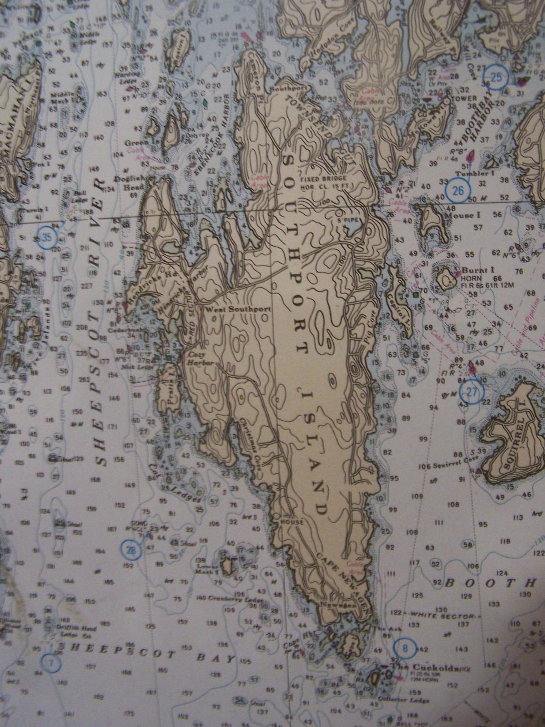
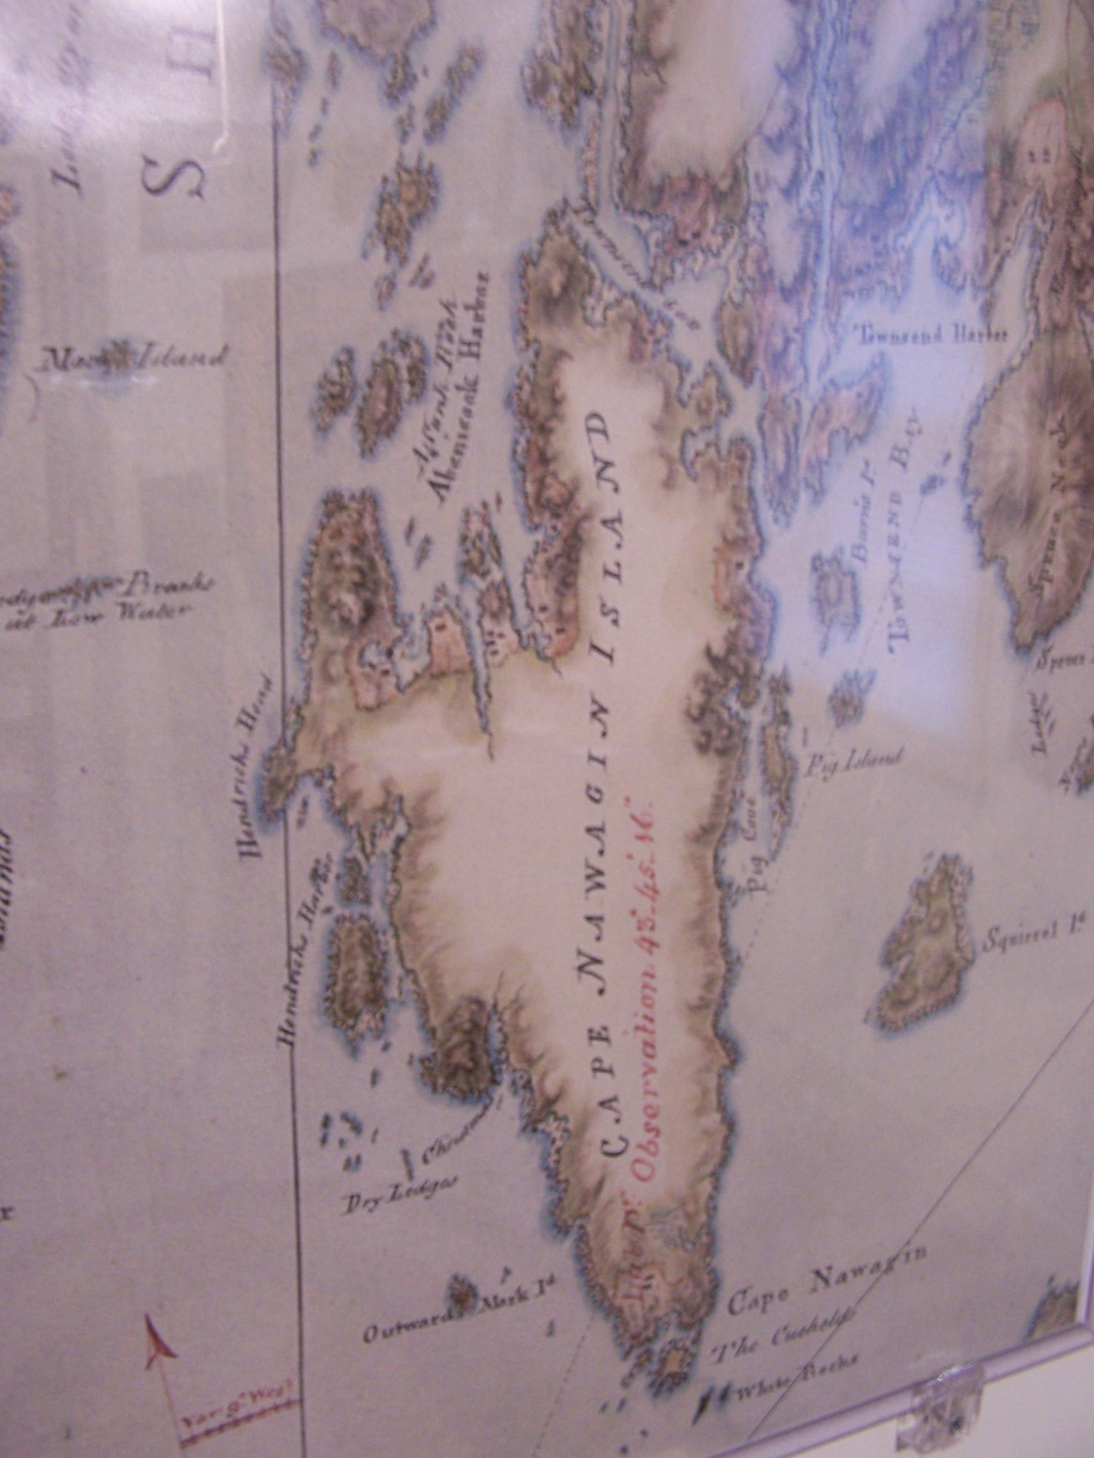
All Officers and Directors were re-elected! See the list on page 8.
Sproule Map
Modern US Chart
Ian Fowler, the Director of the Osher Map Library in Portland spoke about the Sproule map, a copy of which the Museum acquired in 2014.
It is truly a wonder that the early explorers of our coast lived to tell the tale. The contrast between the charts available prior to the mid 1700s and those published later is amazing. The charts prior to 1750 were made by explorers sailing along the coast and not by surveyors on shore. There was no way that a navigator could use the available charts to set a course as we do today. As you can see from the two charts shown above that Sproule knew his surveying and drew a remarkably accurate chart.
To draw an accurate chart one needs to know the latitude and longitude of a starting point and then the relationship of that point with another point to be mapped. The computation of latitude has been known for hundreds of years and most explorers recorded it with considerable accuracy. All one needed was an almanac that gave information about the sun and an instrument that would measure the angle between the horizon and the sun at noon. When Waymouth cruised the coast in 1605 he knew the latitude of Monhegan Island within a few miles. Explorers could find Monhegan simply by sailing to a spot in the Atlantic which had the same latitude as Monhegan and then sailing west. Sooner or later, Monhegan would be in sight.
Longitude was much more difficult to compute because it required one to know the time at some other point of known longitude, often London. The earth rotates 360 degrees in 24 hours so its rate is 15 degrees per hour. If the sun attained its highest altitude on shipboard when it was 3 PM in London, the navigator could figure that in those three hours the sun had traveled 3 times 15 or 45 degrees. Thus the ship’s longitude was 45 degrees west of London. Very simple if one knew the time in London.
In 1707 four ships were wrecked off the coast of England and thousands of lives were lost. The Longitude Act of 1714 offered a prize of £20,000 for the solution to “the longitude problem.” It wasn’t until the 1740s when an English clockmaker named John Harrison built a clock that was accurate enough and portable enough to be carried on a ship that the problem was solved. Read the entire story of John Harrison in Longitude by Dava Sobel.
Now it would be possible to make a really accurate chart of the Atlantic coast of what was to become the United States. Enter George Sproule, an officer in His Majesty’s Navy who in 1772 surveyed the coast. This survey was the subject of Ian Fowler’s talk in June.
To draw an accurate map requires a known starting point and a knowledge of basic trigonometry. The idea is to lay out on the ground a base line, AB, of known length and from the ends of this line measure the angles between the line and another point, M, to be mapped. Trigonometry allows the surveyor to compute the length of AM. Using AM as a new base line the surveyor can find the location of another point, N, and so the process continues. This is precisely what George Sproule did all along the coast of Maine and our map is the result. A testimonial to the genius of John Harrison and the determination and skill of surveyors and mathematicians.
A
B
M
N

Museum Computer

We have a Dell computer at the Museum, running Windows 7, and it is serving us well. Our problem is finding more PEOPLE who understand how to use it. Apparently there is something in the genes of people born before 1973 that prevents them from computer literacy! Our difficulties relate to three areas: Microsoft Access, Filemaker Pro and The Museum Photo Collection.
We would like to be able to answer visitor’s questions, answers to which are in the machine. For example:
- Did Laszlo Simonyi ever own a house on Southport?
- Who donated the Southport Yacht Club sailboat to the museum?
- Do we have a photograph of the old Newagen Inn salt water swimming pool?
It seems unreasonable to expect every volunteer to be able to provide the above information, all of which is in the computer, but it might be possible to ask the visitor to write down the question and then pass it on to a small group who could mail him/her an answer. Could you be one of this group? We need your help? Here are outlines of what the programs are.
Access is a very powerful database and is part of Microsoft Office. It has all the data from the Old House Project which, over the past years has gathered a lot of information about all of the dwellings, summer and year-round, on the island. We need someone who knows about using Access or is willing to learn. He/she would then be able to write a set of directions to allow a person with ordinary computer literacy to add new material to the database and extract information from it.
Filemaker Pro is a more “user friendly” database and does two jobs for us. First it records all of the artifacts in the museum, giving the donor’s name, a description of the artifact as well as a photograph. A second application records all people who contribute money to the Friends of the Southport Historical Society including their names, addresses, and contact information. Donald Duncan is the local Filemaker “expert” and has written a fairly good user manual.
Finally The Photo Collection contains digital images of most of the over 2000 photographs in the Museum Collection. Larry Crane has scanned all of the photographs and is always helpful.
Fundamentally, we are seeking people willing to become acquainted with the museum computer and the data it contains. Data which becomes unavailable because no one knows the software is useless. We need your help or at least your advice. Please send a note to donaldduncan@roadrunner.com or 633-3359.

Gary Snowman’s Book

Gary is a lifelong resident of Southport and is a former Museum Trustee. He is a good writer and is deeply interested in the neighborhood of Cape Newagen, its history and the genealogy of its people, many of whom are his ancestors. He has nearly completed a book, Watching the Horizon. He hopes to have it available in 2016. Gary’s father was Leland Snowman. The Friends have printed two of Leland’s recollections: Out of the Cape and Life As It Was. The rest of this article by Gary is a teaser for Watching the Horizon.

Growing up in the village of Cape Newagen some sixty years ago I was amongst relatives whose families had been settled in the village one hundred and twenty five years before I was born. As a youngster, I enjoyed visiting with some of the aging population where I would listen to the stories of their lives spent at the Cape. Time passes and life seems to fly by until one finds that one has become an elder in the village. Six years ago, I became interested in my family’s genealogy which led to a larger undertaking of writing a history of the families that founded the village of Cape Newagen. The genealogy of the Cape looks much like a large ball of yarn with the entwining families that populated the future generations of the village.
Watching the Horizon is being written with the intent of giving the reader an insight into Cape Newagen individuals and their families and how their lives played out on history’s time line. Watching the Horizon goes into depth of the first founding families of Cape Newagen as well as those who followed. The earliest families at Cape Newagen Village were Chapel, Horn and Preble, followed by Pierce, Lundy, Alley, Gray, Harris, Cushman, Jones and Nelson. Families skirting the village that also had deep influence on the heritage were the Brown, Harley, Poor, and Decker families. Late comers to Cape Newagen in 1880 were the Ayer, Gamage and Snowman families.
Cape Newagen has been the home to European fisherman and their descendents for some four hundred years. Captains and crew were for the most part young lads in their teens an early twenties. Young men of the ages craved the life of a fisherman and wanted to out-fish their competition. Captains thrived in sailing home to port with a full load of fish. Arriving in record time was an ambition that all fishermen sought, but few "high liners" obtained this recognition. Fisherman enjoyed their lives at sea, and fishing was considered a passage into manhood.
Along with the enthusiasm of the young fisherman for his profession was the knowledge of the many dangers that lay ahead on a trip to the offshore "banks". These thoughts were always lying in the corner of his mind. Mother Nature could be unmerciful with fog so thick that one could cut it with a knife, nights so black one might have believed they were in a cave, but the worst were the line gales that come to the Atlantic each fall. Line gales first appear as a normal storm, but within hours turn to deadly hurricane force winds. The noble schooners were no match for winds over one hundred knots that snapped off masts like twigs, and with waves up to twenty five feet that rolled the vessel as she got side to. Fisherman Memorials along the New England coast are full with names of young lads that were swallowed up by the sea. Cape Newagen was no exception with the loss of its young to an unforgiving sea. A visit to the Newagen Cemetery shows that all the founding families had losses with some families losing multiple family members to the sea.
Watching the Horizon is dedicated to all the families and loved ones of the village of Cape Newagen who sat with folded hands upon the Bible and anxiously watched the horizon for their returning fisherman.Villagers checked the horizon for signs of changing weather and peered for vessels in distress. The sea contained their livelihood and means of transportation. The sea gave them their way of life and in a moment could take it all away.
Perhaps the most devastating loss of life to the fishing village of Cape Newagen was the foundering of the fishing schooner W. F. Tarbox. All of the community, most being relatives, were affected on September 15, 1857 when the schooner owned by Samuel Pierce of Marr's (Cozy) Harbor and captained by Ebenezer Lundy 2nd, of Cape Newagen, disappeared with all crew members. After finishing a trip to the Gulf of St. Lawrence, Nova Scotia, Captain Lundy and crew were headed home to Southport with a full load of mackerel. W. F. Tarbox was last sighted passing the Gut of Canso bound for home but disappeared without a trace. The schooner was believed to have been run down by one of the large ocean going passenger steamships that stopped at Halifax to take on coal. The Tarbox was carrying a crew of eight, of which six, including Captain Lundy, were from Cape Newagen.
Captain Ebenezer Lundy’s family loss was tremendous. Captain Ebenezer was born at Cape Newagen in 1826 and married Harriet P. Jones, daughter of Franklin Jones and Mary Nelson, in 1849. Harriet’s mother Mary Nelson was a sister to Jeremiah Nelson who settled on Cape lsland. Ebenezer left Harriet a widow to bring up their two young boys; John, age five and Thomas, age four. Harriet spent the remainder of her eighty seven years at Cape Newagen. The Tarbox not only took Harriet's husband but two younger brothers; Paul, age nineteen and Charles, age fifteen. Captain Ebenezer's older brother Thomas age thirty eight also went down with the Tarbox. The Prebles of Cape Newagen were devastated with the loss of David and Mary Harley Preble's only son, Joseph.
The life at Cape Newagen was always hard but not all was doom and gloom for there were many celebrations of marriages and births, some families had upwards to twelve children. The voices of many children carried in the still evening air and barn dances occasionally were held for the enjoyment of the entire village.
Readers of Watching the Horizon may be interested to view many of the pictures of Cape Newagen and its villagers. Several old photos came from the attic of my Grandparents, Alpheus and Laura Gilman Snowman. The photos seem to have been taken in front of the Newagen House, Cape Newagen's first known inn. The Newagen House was owned by Laura Preble Wilson granddaughter of one of earliest settlers to Cape Newagen, Ebenezer Preble. Two photos taken around 1875, one of all the men of the village and one of both women and men are believed to have found their way to Grandmother's attic by way of Joshua Cushman, first caretaker of Newagen House and an old friend to Grandfather Alpheus Snowman. Many of the individuals in the photos I believe I have identified but perhaps readers of Watching the Horizon could identify others.
Watching the Horizon is still a work in progress requiring finishing several more families of Cape Newagen. The writing of this book has been enjoyable and informative, similar to putting a large picture puzzle together.

Yacht Club Memories
Eugene Huskins

Every square foot of Southport has its own attraction to various people and different times. Cozy Harbor in 1958 to 1961 holds many special memories for me.
One Spring day in 1958, my mother, Estella Huskins, decided that I should take sailing lessons, much to the distress of my father, Alfred, who couldn’t swim, and was very anxious about the whole affair. However my mother was most influential.
The Turnabout was the choice of sailing at the Southport Yacht Club. An older one, number 432, was found and purchased for $200. It needed a lot of work, and my father, who was skilled in wooden boat repairs and building, started in. The Turnabout was a 10 foot plywood cat boat which was user friendly for younger people; wide and stable. My grandfather, Edgar, called it a flour scoop.
Plywood was replaced, turnbuckles and hardware were reconditioned and a leaky centerboard trunk was recaulked. Finally it was time for paint. Father took me to Marine Supply in Boothbay Harbor where we picked out an Emerald Green for the hull, a Light Grey for the decks and interior, White for the mast and boom and a Racing Bronze for the bottom. When she was finished, we trucked her to the Yacht Club, and launched her. One proud kid! And the adventure began.
The first test was to swim about halfway across Cozy Harbor and back, which I did, as Mother had taught me to swim. Norma Smith was the sailing instructor and one of the most memorable people I have ever met; capable and with a wealth of knowledge.
So many fond memories of Gus and Emolyn Pratt, Helen Rand, Bob Colby, Frank Clifford and the many friends and racing competition: Brian Colby, Mark Colby, John Duncan, Marty Donohoe and many others, too numerous to list.
After three years, the sailboat was sold for $200 replaced by a 1952 Ford coupe for $200, which served me well through High School until it too was sold again for $200!

Excursionists Shipwrecked
From Maine Coastal News September 2014

Sloop GEE WHIZ Twice Ran on Rocks in Sheepscot Bay
Passengers Out All Night
Fourteen Bedraggled and Seasick
Persons Finally Landed at West Southport Wednesday

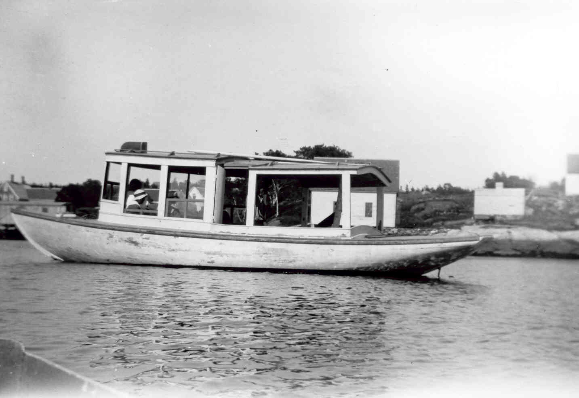
West Southport, August 22 [1906]. - With a weary party of fourteen excursionists on board, the little auxiliary sloop GEE WHIZ crept into this harbor Wednesday after having been lost in the fog and hung up on two ledges on Sheepscot Bay while returning from a dance on the east side of the island on Tuesday night. The party had left Cozy Harbor early last evening. The fog was just then beginning to set in, but with the fog bell from the lighthouse on Hendricks Head to guide them, Capt. E. B. Brewer, an experienced navigator of these waters met with great difficulty in getting back. When the dance, broke up at midnight, the fog was unusually thick even for this part of the coast.
The GEE WHIZ however had little difficulty in coming down the river until she went out by Dog Fish Head as the wind in the channel thus far was well buoyed. But all this time the boat was picking up the sound of the fog horn on Hendricks Head, the engine being slowed down until there was barely steerage way for the little craft and the strong current sent the boat across the river towards the Five Islands shore. While all ears were strained for some sound of the horn or some glimmer of the light, the fog was heavy and the swell which runs at tile point where the river meets the bay, made it almost impossible to keep a true course and the sloop struck.
From the peculiar formation of the rocks here, the captain got his bearings but all efforts to back off the boat from where she struck were unavailing until the rising tide floated her an hour later. With the tide came a heavy swell through which the GEE WHIZ must go two and a half miles broadside to pickup the lighthouse and harbor and many of the party became seasick.
After 15 minutes of sailing the sound of the fog horn could be heard but from Hendricks Point to Cozy Harbor at low tide is very dangerous navigating in the fog on account of the numerous shoals which stretch far out from the Point. To add to the difficulties there are two ledges sheltering the little harbor from the sea. The outer ledge is uncovered for several feet at low tide and in endeavoring to get out of the way of the shoals the GEE WHIZ made too wide a sweep to the southward, and before the low lying rocks could be seen by the lookout at the bow, the sloop had run up on the ledge. All efforts to back her off were fruitless and hold by her bow and swinging and tossing in the heavy surfs from the Sheepscot Bay, the little boat spent an uncomfortable two hours. Nearly all of the party by this time had succumbed to seasickness and their plight was not rendered more cheerful by the knowledge that their harbor lay barely a hundred yards away. After a time the tide lifted the GEE WHIZ over the outer ledge and the anchor was let go for it was impossible for the helmsman to take even a small boat through the very narrow channel by the inside ledge in such a fog. Fortunately the stout hull of the sloop had been but little damaged by her experiences on the rocks and the excursionists were subjected to no more harrowing adventures. During the forenoon the fog had lifted sufficiently for Capt. Brewer to make out the bar that marked the inside harbor ledge and without further mishap the GEE WHIZ landed her bedraggled party on the wharf.

Do It Yourself

Perhaps some of the articles have triggered your own memories of Southport days. We are soliciting stories for future newsletters, and if you would like to put one on paper we would be delighted to consider it. Do give it a try! Everyone has a story. Just write it down, and send it to donaldduncan@roadrunner.com

Books for Christmas

A quick reminder that copies of Island Tales @ $10, Historical Gleanings @ $5, The Old House Book (old edition) @ $5, Leland Snowman’s Out of the Cape @ $5, Luther Maddocks’ Looking Backwards @ $5 and I’m Different (Ethelyn Giles) @ $5 are still available for purchase by mail. Include $5 for postage and packing with each order. Please make checks payable to The Friends of the Southport Historical Society and send to Donald Duncan, 32 Blair Road, Southport, ME 04576.

Without our Volunteers we could not operate. There have been a total of 866 volunteer hours since last November. This year we had 337 visitors from 27 states, Quebec and Germany. Again we give special thanks to Nan Jackson who scheduled all the guides. She kept careful track and hardly anyone missed an assignment!

John Buck
Kathy Bugbee
Ann Charlesworth
Phyllis Cook
Larry Crane
Karen Curtis
Fleet Davies
Peter Doelp
Donald Duncan
Joyce Duncan
Bob Eaton
Gerry Gamage
Anne Grimes
Tim Hanley
Dan Harle
Jean Hasch
Jean Hawley
Toni Helming
Gene Huskins
Nan Jackson
Hilary Jacobs
Shelby Kaider
Merry Knowlton
Mary Lou Koskela
Bill Messmer
Cathy Messmer
Meredith Mitchell
Ralva Orchard
Ronald Orchard
Michael Pollard
Nancy Prisk
Ann Roche
Evelyn Sherman
Sarah Sherman
Becky Singer
Jim Singer
Dick Snyder
Pegi Stengel
Jean Thompson
Priscilla Wallace
Lois Weeks
Bruce Wood
Carole Zalucky

Friends of the Southport Historical Society
P. O. Box 3
Southport, ME 04576

Museum Trustees
Ronald Orchard, Chairman
Kathy Bugbee, Secretary
Mary Lou Koskela, Treasurer
Phyllis Cook
Donald Duncan
Bob Eaton
Jean Hasch
Gene Huskins
Bill Messmer
Evelyn Sherman

Friends Directors
Dick Snyder, President
Jean Hawley, Vice President
Carole Zalucky, Secretary
Becky Singer, Treasurer
Kathy Bugbee to 2016
Nan Jackson to 2016
Shelby Kaider to 2017
Ann Roche to 2017
Larry Crane to 2018
Tim Hanley to 2018

Phyllis Cook (Emerita)

