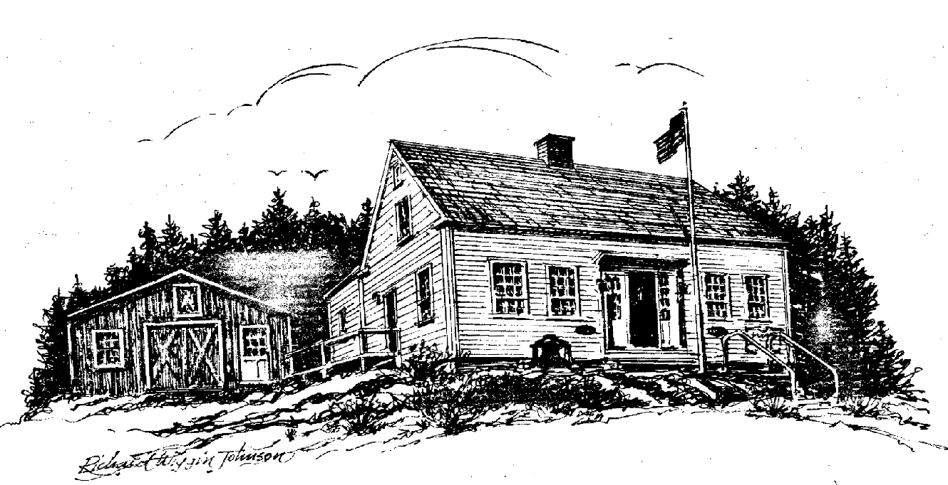

Friends of the

Southport Historical Society

P. O. Box 3, Southport, ME 04576

HENDRICKS HILL MUSEUM

Newsletter ***** November 2010

Donald Duncan, Editor

MYSTERY LADY OF HENDRICKS HEAD

Much of the following is abridged from an article in the Lewiston Sun Times c. 1956. With many thanks to Ron Orchard.

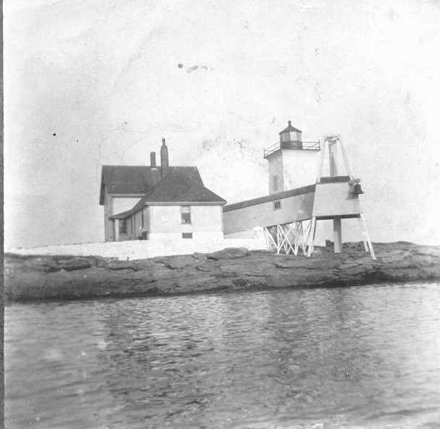
The story begins on the afternoon bus to Boothbay Harbor on Tuesday, December 1, 1931. Where did she come from to take that bus? She registered at the Boothbay House as Louise G. Meade and asked several persons where she could get a very good view of open ocean.
She started on the road to Southport, not an easy trip to undertake on foot, especially on the short afternoon of a windy December day. She knew about Hendricks Head (Lighthouse pictured at left), that is for certain, because when she met Mrs. Pinkham the name was not unfamiliar to her.
Mrs. Pinkham was on her shift at the West Southport Post Office. The woman was walking along the road, almost in front of the store. “She was medium height,” recalls Mrs. Pinkham whose memory is sharp as a tack, “and she was dressed in deep black. I remember thinking I had never seen her before, and in those days I knew most everyone who came to Southport, winter or summer.”
The woman stopped when she saw Mrs. Pinkham. "I'm on my way to the ocean," she said. "Which way shall I go?"
"You’re near Hendricks Head," Mrs. Pinkham said hesitantly. "But it is beginning to get dark. And it's windy and the road is lonesome down there." The woman thanked her and left heading for Hendricks Head.
Soon Mr. Knight, keeper of the Hendricks Head Light, arrived at the post-office-store. The minute he came in Mrs. Pinkham asked him if he had met the woman on the road.
"I didn't meet anyone."
"But you couldn't have missed her. She couldn't get down past your road this fast."
"I'll keep an eye out for her on the way back home," said keeper Knight. "Kind of funny, isn't it?"
On his return trip to the light, keeper Knight kept a sharp eye out as he walked. Darkness was closing in. He knew that road, like the palm of his hand, and he kept scanning the roadside, listening intently, trying to make out any strange sounds above the noise of the rising wind and the wash of the tide. He thought he might have seen someone, called, and received no answer.
He was home in a matter of minutes, and he told his wife about the woman and about the movement he thought he saw. It was really dark now. His wife had not seen anyone on the road. They agreed he couldn't have seen anything near that cottage and yet both of them were worried.
Stories have sprung up in the last quarter century. There is the story that her family fortune may have been wiped out in the stock market crash of 1929 because obviously she was a woman of breeding and background. But why did no one ever come forward, if she had been from a family of position or wealth? Somewhere, somebody should have recognized her description, noted that she had dropped from sight.
Why did she come to Boothbay Harbor and Southport? She seemed to know the territory, be familiar with the landmarks. She did nothing, during the few hours she was there, to arouse suspicion other than walk off down a lonely road in the late afternoon of a December day. The name Louise Meade meant nothing to anyone, yet it is an acknowledged fact that even when people assume false names they take one that either has the same initials as their own name or sounds very similar.
The labels on her clothes, the only identifying mark ever found, were Lord and Taylor, the fashionable New York City store. But those labels never helped at all. Nobody ever found out a thing about her, although detectives searched and searched, and her description and her story ran in papers throughout the nation.
Some people claim that she was mixed up with liquor smuggling, that she had gone down to the coast that late afternoon in 1931 to signal a liquor boat. Remember that this was the Prohibition era and the broken coastline of Maine in those years has a history that has never been written. Those are the ones who say she died because she knew too much or because she double crossed someone. "Nonsense!" says Mrs. Pinkham who was born a Brewer and has generations of coastal Maine behind her. "She wasn't that sort. I talked with her. She was a nice woman, a refined woman, a lady!"
By the next morning everyone in Southport was a "little worried." The woman in black had not returned. "We became curious," is the way Charlie Pinkham puts it, so Willis Brewer, a Southport fisherman, went looking for her. He had no trouble picking up her tracks. He followed her path to the beach where, they have always believed, she probably watched the water.
Charlie Pinkham, who among all his other duties, for years has been one of the guiding lights of the Southport Volunteer Fire Department, goes on with his story: "After six or seven days I asked some of the firemen to help search the shore, so on Sunday, December 6th, I took one or two men and scanned the shore, starting at North Beach, following west and north."
"Stanley Orchard with other firemen started at South Beach, going west and north. Stanley arrived at the ledge south of the little sand beach at about the time I arrived on the ledge at the north end of the little beach. Stanley was gazing into the water and all of a sudden said: "There she is!"
"The undertow was washing the body up near the surface, then letting it back into the depression about six feet under at that time of tide. I asked the fellows to keep an eye on the body while I rushed for the lighthouse to obtain line and hook to throw over to catch her clothing.
"By the time I returned the men had hailed Link Webber in his boat. He came and took Hiram Moore and Scott Gray aboard. They fastened a line around the body and towed it in on the North Beach. The bag left at the hotel as well as the one fastened to her belt, did not have any evidence as to who she was or where she came from. She was well dressed in black from Lord and Taylor, New York City. No evidence whatsoever was found to identify this woman, who may or may not have been Louise G. Meade."
They tried to identify her, before it was over, detectives came down from New York City, her description was broadcast to every police department, people were interviewed, Missing Persons Bureau was checked and rechecked. Newspapers carried the story. Every day a "sure lead" would develop only to get nowhere. Nobody ever came forward to say they ever had even heard of this well dressed, well-spoken, well behaved gentle woman.
The general theory is that she drowned herself. She is listed in the medical records as suicide; Charlie Pinkham goes along with the suicide but not with the drowning.
Finally on January 8, 1932, the Town of Southport buried her in the old cemetery on the road to Hendricks Head. Names on the monuments in that cemetery are names noted in Maine history, sea captains, early settlers, Southporters. There is no Potter's Field in this town. There is no need for one. So they took the woman known as Louise Meade to "their" cemetery and gave her a decent burial.
The only markings on her grave are a few field stones, put there mainly to mark a gravesite. Already many of the younger generation do not even know where the lady in black is buried. Charlie Pinkham can take you right to the spot. It is under a giant tree, a little off to one side because this is a cemetery of families and the only place for a single grave is "off-to-one side".
"Wouldn't think a person could just drop from sight like that, would you?" says Charlie Pinkham. "But she did. Nobody ever came forward to claim one thing about her. Lord knows, we advertised. Kinda funny, when you think about it."
The over three quarters of a century since she "dropped from sight" has been an eventful one and the woman known as Louise G. Meade could well be forgotten under ordinary circumstances. But there was nothing ordinary about this woman's impact on Southport Island. She isn't forgotten. A blank grave marker has been placed on her grave.

CHARLIE PINKHAM' S SOLUTION

"My theory, and mind you, this is just my own theory, is that she sat on the beach and took poison. No autopsy was performed so there was no proof. But here's how I figure it. When she was found it was in a spot a few feet south of this beach. She had a leather belt fastened around her wrists and then the belt was run through the handle of an electric flatiron, (that was to weigh her down) and through the handles of her handbag. One hand was hooked on her belt. The other hand, the thumb, was inside the catch of her bag which was partially opened.
"Now I've seen plenty of drownings, some accidental, some not. And I've yet to see a person who cast himself into the water, regardless of how great was his desire to die, but what at the last moment, when it was too late, that will to live made him reach out, trying to grab back life. This woman’s hands had not moved. That's why I always will believe it was poison. The tide would take her out into the water. The iron would weigh her down."

DOC ROCKWELL

In the 1970s Barbara Rumsey interviewed several people in the Region and videotaped the results. One of her interviews featured Ruth Gardner and Ruth Potter reminiscing about Doc Rockwell. Larry Crane has put this interview onto a DVD and has added many maps and pictures and clips of Doc Rockwell performing on the Fred Allen Radio Show. He showed the DVD in August to an audience in the Town Hall. The old recording did not reproduce the sound very well, but the pictures were great and Larry’s editing with maps and so forth were wonderful.
The Museum has a small exhibit on Rockwell and here is some information on a very interesting and talented man.
Rockwell was born in 1889 and early on showed a talent for drawing and quick thinking. He was a skilled magician and performed in the B. F. Keith vaudeville theaters. The act ahead of him featured animals who were fed bananas. One evening on a whim he grabbed a bunch of bananas and shouted to the audience, “Who likes bananas?” He developed the idea of tossing bananas to those parts of the audience who applauded most vigorously. One evening the great stalk of bananas was empty and there were none to toss. He looked at the empty five foot high stalk which was probably hanging from a cart, and it resembled to him a human spine. His quick brain thought it would be funny to launch into a lecture in anatomy and the ailments of a bad back. This proved to be a smashing success, much as the recitation of Casey at the Bat became an expected part of each performance of actor DeWolf Hopper, and he incorporated it into his future acts. Thus the nickname, Doc.
“They tell me that, like Samson,” said Rockwell, “I slew my thousands, but instead of using the jawbone of an ass, I give the banana stalk credit for most of the destruction.”
He worked with many of the famous names of the 1930s: Fred Allen, Jack Benny, Groucho Marx, Fanny Bryce and George Burns, often earning the then fabulous wage of $3,500 a week! But the bright lights of New York paled and he found solace in the smaller towns, particularly Boothbay Harbor. He bought a house on Beacon Hill in Southport and lived there with his long term friend Madelyn Meredith, a petite woman who sold real estate in the region. He named the house Slovenly Manor and published a monthly magazine entitled George Rockwell’s Mustard Plaster featuring cartoons, jokes and articles.
One of his articles and several copies of The Mustard Plaster are on display at the Museum along with his rocking chair:

The Discovery of Boothbay Harbor
A 500 Word History of the Famous Resort
by
Doc Rockwell

Nobody knows exactly who the first settler of Boothbay Harbor was. But from all present observations it was some man by the name of either Brewer, Giles, Greenleaf, Dodge, McKown, Kelly, Lewis, Perkins or Reed. These people did for the Boothbay Region what Brigham Young did for Salt Lake City and as a consequence the town received a charter from Sears, Roebuck and Co. and was officially chartered in 1573.
Its geographical location makes it ideal as a summer resort. Situated at the extreme end of a peninsular (sic), it is not easily accessible by railroad and accordingly is not visited by every Tom, Dick and Harry. This fact appeals to the families who would like to enjoy their cottage without being swooped down upon by self invited relatives and presuming acquaintances.
It is also the heart of the fishing and shell fish industry of the Northeastern part of Central southern Maine. If the lobsters caught within five miles of Boothbay Harbor in a single day were laid end to end on the Post Office steps, it would keep many people away from the window and give the clerks a better chance to read the post cards.
There are many other towns and villages within a short distance and Boothbay Harbor has a drawing population of several thousand and a painting population of about the same number especially during the summer when the artists are here. Some of these people are interior decorators and do wonderful work with Jamaica ginger and vanilla extract. All of which makes it hard to believe that Boothbay Harbor is located in the temperate zone. But it is.
The climate is ideal for raising blueberries, whiskers, and money to buy the minister a new carpet sweeper for the parsonage. The winters are mild and the summers are cool, many people sleeping under blankets every night as a protection against the mosquitoes, which seem to be able to penetrate any number of sheets. But mosquitoes are only found in a very few places and there are really no pests with the exception of several young men who have been paying their tuition in some Barber College for the past ten years, by selling subscriptions to the Saturday Evening Bath.
The principle industries of Boothbay Harbor are the manufacture of grandchildren, good dispositions and reasons why the Eastern Steamship Co. won’t run a boat here from Boston. The government consists of a Board of Selectmen, several women’s societies and a Civic Club.
If you would like further information about anything in this region listen in on any one of the eighteen party telephone lines. You can’t go wrong in Boothbay Harbor – without everyone knowing it.

Doc’s discussion of Dentistry and the Economy from The Mustard Plaster of January 1929.

Dentists use offices; offices have to be built and require light and heat; all of which gives work to a certain number of people. These people have to have home, food and clothing, which employs a still greater number of people. This last number require automobiles, telephones, books and amusements, etc, and so we begin to see the prosperity which indirectly results from our having our teeth regularly attended to, for ultimately all these extra people who are kept busy will have trouble with their teeth. Thus the business of dentistry increases and somewhere in the scheme of things each of us gets our finger in the pie, clearly demonstrating that proper dental attention means not only health but wealth.
The dental profession is co-operating splendidly in this unorganized campaign for prosperity by recommending that the teeth be brushed up and down instead of horizontally. For in up and down brushing it is practically impossible for the bristles to get under the gums and clean and remove deposits but they can and do push food particles beneath the gums.
This is a foothold of decay, which will speed up the wheels of commercial progress, the hum of industry and the groan of orthodontistry. Vertical brushing also saves wear and tear on the tooth brush.

In addition to his writing and performing, he had great talent in sign painting and Southport’s current sign painter, Jeff Brown, remembers swapping ideas with Doc and being given some of Doc’s paints and brushes by Rockwell’s son after Doc’s death in 1978. Several of Doc’s signs like the one at the left are on display at the Museum.
He is buried next to Madelyn in Southport’s Decker Cemetery.

SOUTHPORT HOUSE HISTORY
Cathy Messmer

The Annual Meeting of the Friends in June provided an opportunity for us to update the Southport community on our efforts to record the history of the houses on Southport. This is a project that was inspired by the publication in 1988 of the Old House Book which told the stories of many of the older houses on the island. A few years later, the Friends decided to begin to collect historical information about island houses that hadn't been included in this very popular book. In doing so, our goal has been to learn more of the history of our island and to share this information with townspeople and visitors.
In 2003, Jean Hawley got the new Southport House History project, as we call it, started by sending property owners a questionnaire asking for information about house construction dates and the chain of owners through the years. She received approximately 100 responses containing a treasure-trove of information, photos and stories. To organize and store the information, she used modern technology in the form of a database which could be updated as more information became available. Jean spent many, many hours entering the newly gathered information into the database.

In 2008, Meredith Mitchell, Henry Wyatt, Cathy Messmer and Todd Merolla joined Jean in her efforts to be sure that we have at least basic information for every house on the island. This intrepid group has been traveling the roads of Southport, interviewing residents who have knowledge of the history of their neighborhoods and sifting through public documents at Town Hall. This past spring, Larry Crane helped us with updating the Microsoft Access database, not a simple task, as it turned out. That accomplished, we are now at work entering the newly acquired information into the database. As we move forward, we hope to link the house history database to historic photographs and deed information already available in the museum’s computer. This will make it easier to those who are interested in tracing the history of their house or cottage to access all the relevant information available at the museum.

During our presentation at the annual meeting, we shared some of the information, photographs and maps that we’ve collected so far. Meredith Mitchell, who has been gathering information in her Newagen neighborhood, used photographs as well as a Google Earth map, a Southport tax map and an old Sunset Rock Plat map to help tell the story of the stone house on Bayberry Lane now owned by Catherine Herter. The story had a personal connection with Meredith in that the house was built by in the 1950s and 60s by her uncle, Douglas Norman Pierce. She remembers helping her uncle by hauling rocks in her wagon! Meredith’s presentation included the story of another house in Newagen, Tom and Barbara Lally’s house in the Newagen Colony. This house was built by Joshua Brooks to house his family. It was built 100 years ago this year. Brooks once owned the Newagen Inn and all the land that became the Newagen Colony.

Cathy Messmer told about her own house on Cosy Harbor Road. While searching for information about their house, her husband Bill found old maps and photographs, deeds, wills and property inventories of previous owners which helped him trace the ownership of the land back to 1768. They were surprised to learn that there was an earlier house on the property by 1846 and that the owner of that house, Thomas Pierce, operated a dry goods store out of a small building located in front of the house by the side of Cosy Harbor Road. Cathy showed early photographs of this building which later served as the island’s post office. In the 20th century, it was moved back just a bit and is now incorporated in Leonard and Mary Merrill’s house, next door to the Messmers.

The audience got involved that evening when Cathy “challenged” everyone attending to identify the buildings in some old photographs. While the crowd didn’t earn an A+, they were able to place most of the photos. Among the buildings included were the old Rand house, now the Pellarin house at 17 Landing Road, the Stephen Thompson house on Beach Road, presently owned by the Metcalfs, and an instantly recognized photograph of the houses in Pig Cove on the east side of the island.

As a follow-up to this presentation, the Friends sponsored a July workshop entitled “Researching the History of Your House.” Conducted by the Messmers, the workshop filled quickly. Interestingly, most of the participants had already started work on their house histories and enjoyed the chance to share their experiences with the others. Our ulterior motive in offering this kind of workshop, of course, is to encourage home owners to share information about the history of their properties with us so that we can include it in our house history database. We plan to offer the workshop again this coming summer.

If you would like to get involved in the Southport House History project or if you have some information about or old photos of your house or neighborhood, please contact Cathy at 633-4807. We thank wholeheartedly all of you who have already contributed!

CONTINUING GRATITUDE TO GWI

The Museum continues its use of Great Works Internet web connections. GWI grants this service to non-profit organizations at a very nominal cost. This allows us to have our website at hendrickshill.org which is overseen by our webmasters Bruce Wood and Larry Crane. We express our continuing gratitude to them all.

VOLUNTEERS

Without our Volunteers we could not operate. They write and contribute to the Newsletter, clean the Museum in the spring and put her to bed in the fall, keep the gardens cared for, put on a volunteer luncheon, record your changes of address and your generosity and keep track of the accessions. Some paint signs and help with electrical work. Some tame the computer and keep up the website. Others write checks and keep us solvent. Some simply smile and encourage the rest. If you have a skill you would like to share, do let us know.
Evelyn Sherman reports that there have been a total of 1,745 volunteer hours since last November. This year we had 269 visitors from 21 states. A visitor from Florida opined “You have a gold mine here!” and a New Yorker said, “I visit every summer and it just gets better.”
If you have not visited us, why not?

At the very top of the list of faithful volunteers is Evelyn Sherman

If with pleasure you are viewing any work a woman’s doing,
If you like her or you love her, tell her now.
Don’t delay your approbation ‘til the parson makes oration,
And she lies with snowy lilies o’er her brow.
For no matter how you shout it, she won’t really care about it.
She won’t know how many teardrops you have shed.
If you think some praise is due her, now’s the time to slip it to her,
For she cannot read her tombstone when she’s dead.

Let us all rejoice that Evelyn has chosen to give so much of her time and enthusiasm to the welfare of the Museum. Along with her husband, Maurice, and others, she was among of the original Trustees of the Museum, and well before that was working on the Old House Book and Historical Gleanings. No scrap of dust or misplaced artifact escapes her watchful eye, and hundreds of visitors have felt her knowledge and love of Southport. The Museum has many treasures, but Evelyn is surely one of the best.

Those who helped in 2010:

Jack Bauman
MaryAnn Blycher
Sally Bobbitt
Marion Bradley
Jeff Brown
Kathy Bugbee
Barbara Bush
Ann Charlesworth
Rick Conant
Phyllis Cook
Larry Crane
Karen Curtis
Maria Doelp
Peter Doelp
Donald Duncan
Joyce Duncan
Bob Eaton
Leanne Eaton
Gerry Gamage
Anne Grimes
Jean Hasch
Mimi Havinga
Jean Hawley
Toni Helming
Nan Jackson
Shelby Kaider
Mary Lou Koskela
Bill Messmer
Cathy Messmer
Meredith Mitchell
Ralva Orchard
Ronald Orchard
Michael Pollard
Evelyn Sherman
Kit Sherrill
Becky Singer
Jim Singer
Dick Snyder
Ralph Spinney
Pegi Stengel
Jean Thompson
Priscilla Wallace
Bailey Weeks
Lois Weeks
Bruce Wood

Friends of the Southport Historical Society
P. O. Box 3
Southport, ME 04576

Museum Trustees
Ronald Orchard, Chairman
Kathy Bugbee, Secretary
Mary Lou Koskela, Treasurer
Rick Conant
Phyllis Cook
Donald Duncan
Bob Eaton
Jean Hasch
Bill Messmer
Evelyn Sherman

Friends Directors
Dick Snyder, President
Jean Hawley, Vice President
Shelby Kaider, Secretary
Joyce Duncan, Treasurer
Cathy Messmer to 2011
Meredith Mitchell to 2011
Larry Crane to 2012
Becky Singer to 2012
Kathy Bugbee to 2013
Nan Jackson to 2013
Phyllis Cook (Emerita)

Apologies to the author, Berton Braley, for minor changes.

