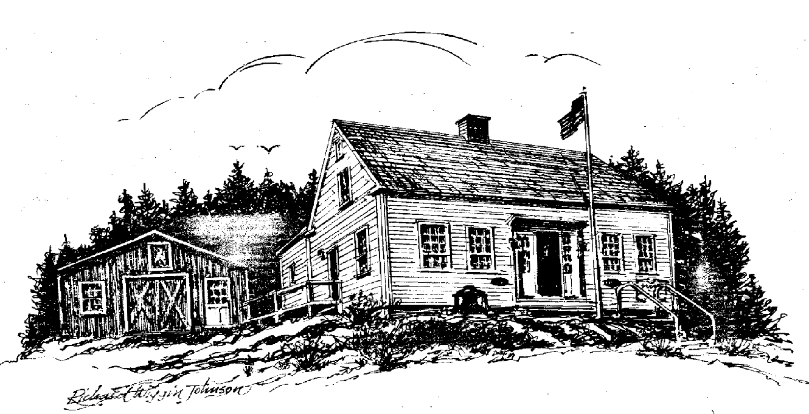

Friends of the

Southport Historical Society

P. O. Box 3, Southport, ME 04576

HENDRICKS HILL MUSEUM

Newsletter ***** November 2011

Donald Duncan, Editor

ISLAND TALES HITS THE STREETS

Just in time for the Annual Meeting in June, the Lincoln County Publishing Company called and said that our order of 1,000 copies of our new book of Southport Stories was ready. Many of you have already seen the book and we are undyingly grateful to you who have bought a copy and to several stores and locations that have sold them for us, including the Southport General Store, Sherman’s, the Southport Memorial Library to name just a few.
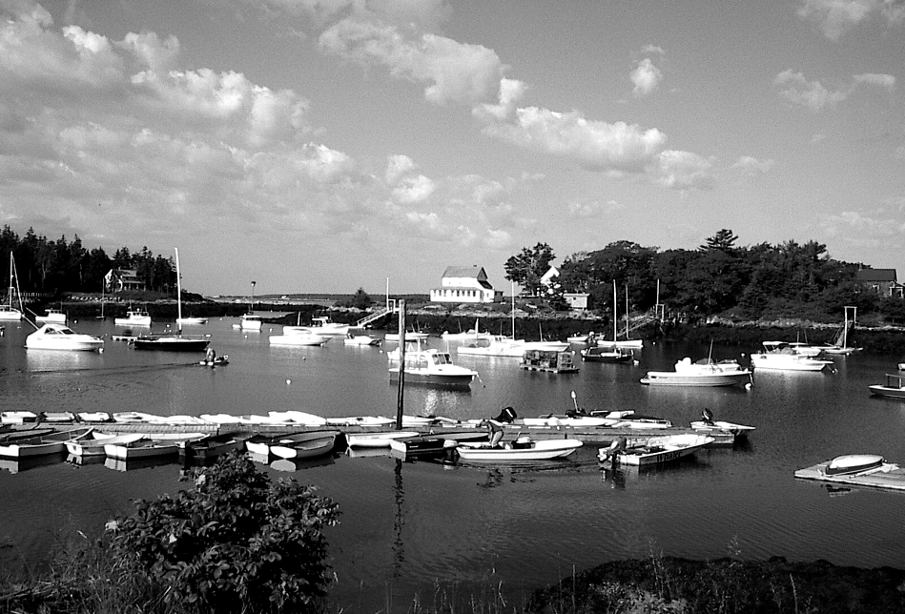
Island Tales, with Ron Orchard’s fine cover photograph of Cozy Harbor shown at the left, brings to light glimpses of the stories and the people who have been a part of Southport’s history over the last 400 years. There was Daniel Strout who rowed regularly from Bath to Newagen to court his bride-to-be before they eventually became the founders of the Bay View House at the foot of what is now Strout Road. There was Royal Luther who built the second lighthouse at Hendricks Head after the first one burned, and stayed to marry a local girl. There was Bob Speed who was perhaps Southport’s first hippie in the 1950s and 60s.
The list isn’t endless, but it includes the mysterious Louise Meade who disappeared near Hendricks Head in 1931, Molly Casey of Mollys Point and the Brewers: Nahum, Ob and Jesse. There are the store owners Bub Gray, Everett and Charlie Pinkham as well as Howard and Weltha McKown. You will get a glimpse of Joshua Brooks who opened the Newagen Inn in the 1920s and who rebuilt it in the midst of World War II after the 1943 fire. We think you’ll be amused at the stunts played with the old Town Hearse and a well-known realtor’s response to the statement, “I don’t have $2,100 for a down payment.”
We have already sold over 300 copies at $10 each and they are also available by mail by sending $15 for one copy or $25 for two copies which will be sent post paid and post haste. Think of all your friends and relations who would enjoy Southport for Christmas. Send orders to PO Box 3, Southport ME 04576

THE INVENTORY ELVES

Fifteen years ago, Evelyn Sherman asked for help with the 3x5 cards that then carried the information on the Museum’s Collection. The age of 3x5 cards was fast coming to an end and through the generosity of the Friends, we bought a database computer program by which we could record many pieces of information on each artifact: first and last name of the donor, date of donation and so forth. Recently we discovered that it was relatively easy to take pictures of artifacts and attach the picture to the record.
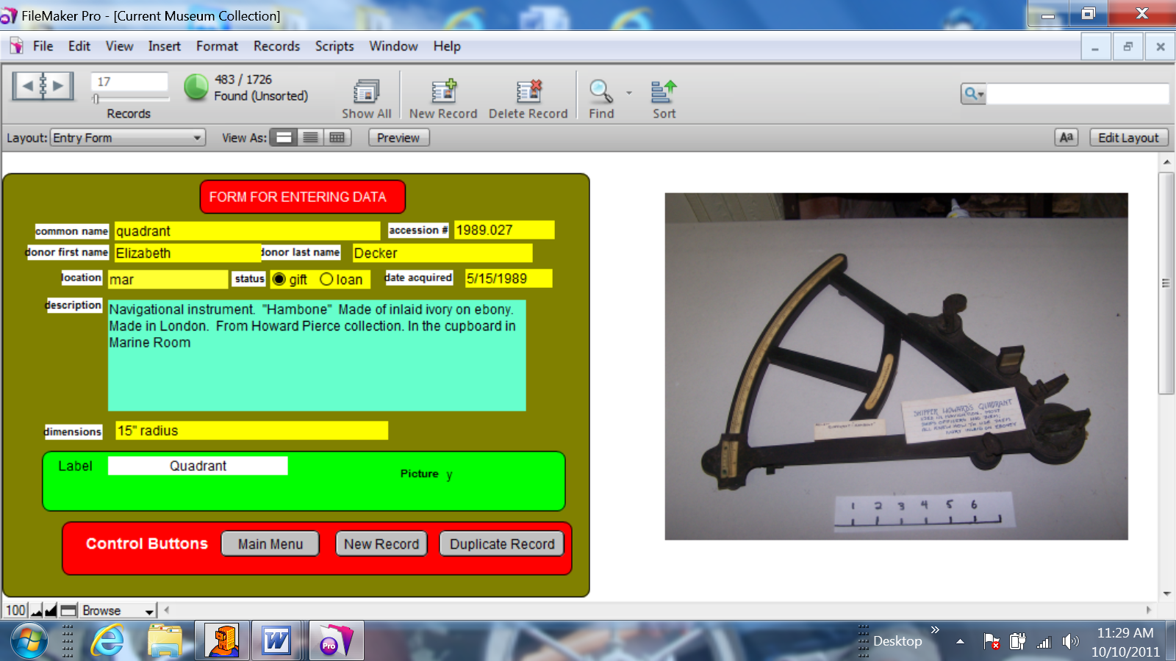
Last winter, Evelyn Sherman, Jean Hawley, Cathy Messmer, Meredith Mitchell, Nan Jackson, Carol Zalucky and Donald Duncan began the process of going through the collection item by item to be sure we had all the relevant information in the computer. The picture below shows what the computer screen looks like for the navigational instrument that was the 27th item acquired in 1989 and is now displayed in the Marine Room.
We have found about 250 items that somehow “snuck in” to the building without being properly accessioned and they carry an accession number like 2011x.127 as being the 127th item that was accessioned in 2011, but which had been acquired previously.
We are continually amazed at the supply of information that Evelyn has stored in her head. When we find an item that has not yet been accessioned, nearly always Evelyn can tell us all about it. There is a small, bright blue wooden wash stand in the Guest Bedroom with a water pitcher and bowl on top. No accession number. “Oh yes”, says our source of all information, “That pitcher came from Janet Appell. There was a matching bowl, but, carrying it downstairs, she dropped it and it smashed, so we replaced the bowl with another. I’m not sure where the bowl came from, but Jean Thompson and I picked up the washstand from a lady who answered our newspaper ad! The color of the washstand is a bit wild.”
The process was greatly simplified when the Friends bought us a new laptop computer so that we could easily bring the laptop to the room being inventoried rather than having to carry items to the Reference Room for entry into the desktop computer.
The next step is to get the right accession number permanently attached to each article. With the above information properly recorded in the database, that will require much less local knowledge. We are eternally grateful to all the elves who help the Museum to operate so well.

SOUTHPORT HISTORICAL INFORMATION HUNT

The Sixth Grade students at the Southport Central School have been working on a fundraising project to support their trip to Washington DC. In July they had a Southport Information Hunt. They set up several stations around the Island where participants were shown historical pictures and asked for answers to questions.
Many of the answers could be found at the various stations so our gentle readers may have considerable difficulty. For instance one of the stations was at the Fire House and pictures of various Chiefs and Fires were on display
There were several teams that paid a fee to enter and then were scored on their answers. Several stores and restaurants, including Newagen Inn, Boothbay Region Boatyard and Robinson’s Wharf donated prizes. Here is a list of the questions:

- Name Southport’s four Fire Chiefs.
- What were Southport’s three biggest fires?
- How many fire trucks does the Southport Fire Department have?
- Part of the Fire Department’s building was originally an old school house. Where was it moved from?
- How many post offices have there been on Southport and where were they located?
- Name three Southport General Store owners, past or present.
- What was the symbol on the Southport Yacht Club’s first flag?
- Name a founding member of the Club.
- What is the significance of the building that was moved from the Cozy Harbor House by Lizza Giles and his horses Babe and Chub in 1939?
- Where was it moved to and what did it become?
- True or False? Southport had its own two year high school.
- Where was it located?
- What did it become?
- Where was the Cozy Harbor House moved to?
- What was Margaret Hamilton’s first job before she became a Hollywood actress?
- What are the denominations of Southport’s two churches?
- Where have they been located on Southport Island over the years?
- Where are Southport’s two lobster pounds located?
- How many pounds can the East Side lobster pound hold?
- How many bridges have there been on Southport Island over the years?
- Name the family who were the last to live in the bridge tender’s house.
- Name five Southport fishermen – Past or Present.
- Name the famous Arctic Explorer who tied up a Robinson’s Wharf.
- What was the name of his schooner?
- Who was the explorer’s good friend and was the owner of the wharf?
- There were originally four steamboat landings on Southport Island. Name the location of one of them.
- Name Southport’s three lighthouses.
- How much money was appropriated by Congress in 1829 to build Hendricks Head Lighthouse?
- What was cut on Sawyers Pond and loaded onto schooners?
- Why was this local resource so valuable?
- How many campsites are there at Gray’s Campground?
For your convenience, the answers are given later in this newsletter.

ANNUAL MEETING OF THE FRIENDS

On June 20, the Friends held their Annual Meeting at the Town Hall. Carol Zalucky replaces Shelby Kaider as Secretary and Meredith Mitchell and Cathy Messmer were reelected as directors until 2014. Shelby has served for several years and we are very grateful for her devoted service.
Becky Singer and Lois Rand Weeks presented an illustrated talk Dead People Can Talk. For several years they have been collecting data from various cemeteries throughout the country searching for genealogical material. Ron Orchard had made a list of all graves on Southport and they took on the task of cleaning and photographing all the gravestones. Their talk emphasized the difficulty of cleaning and reading old stones. No chemical cleaners can be used and sometimes mud is put on the stone to make inscriptions more legible.
Often stones will contain a carving of a hand with a finger pointing up to indicate their hope for heavenly rest. In the Twin Coves Cemetery, they found a stone memorializing a woman with the hand pointing to the right. This puzzled them until they investigated the graves to the right and found that the woman had outlived five of her children who were buried there. She apparently hoped to join them in heavenly rest.
On a humorous note they found in a Key West Florida cemetery the grave of a woman who died at fifty. She was apparently known as the local hypochondriac because her stone read, “I Told You I Was Sick.”

MACE CARTER BARGE

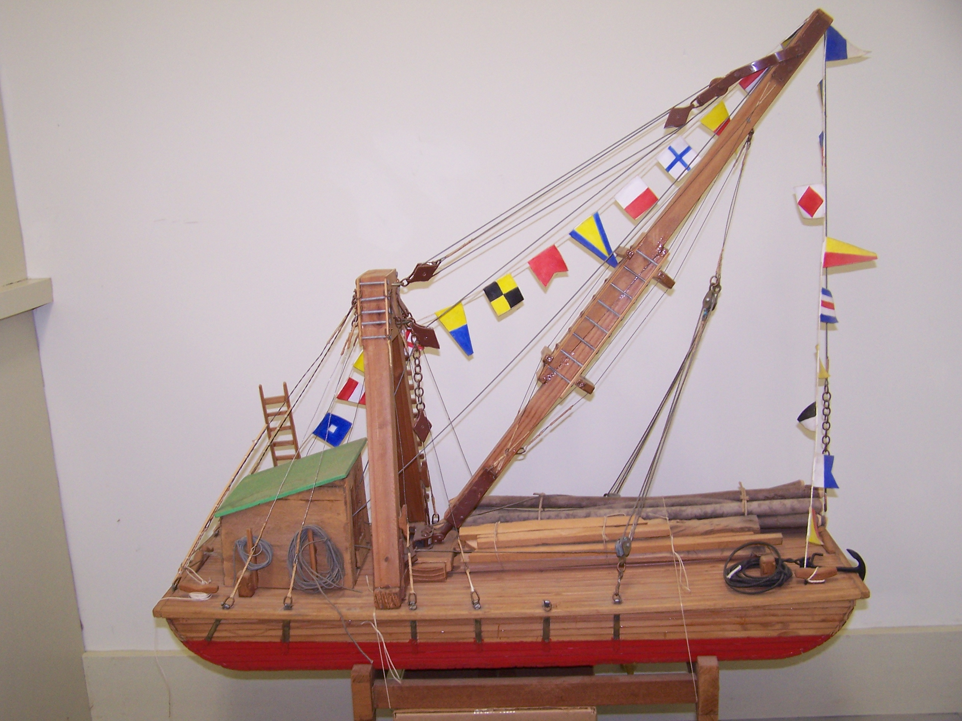
This fall, Skip Rideout gave to the Museum a model built by Alvin Brewer of Mace Carter’s barge. Mace was a marine contractor in the middle part of the 20th century. We will have a case built for it, and it will be on display in the Boatshop next summer. Under the derrick on the deck are several piles that could be driven into the sea bottom.
The anchor that is shown at the bow of the barge is currently on Davids Island. The building at the stern of the barge housed an engine that operated the crane. There were no hydraulics, and it is clear that the entire operation was run by block and tackle. The Museum is delighted to have so well-made a model showing how marine work was done in earlier years.
This may well be a place to quote the dedication to Mace on the Boothbay Harbor footbridge: “What ever he did, he did well,”

GRAMPA BETTER COME

A small boy visited the museum with his mother. Ron took special interest in the young man and showed him around. When the mother had finished her tour, the boy was still entranced and reluctantly left with the words, “Grampa better come.”
Later Grampa did indeed come and both he and his grandson left convinced that the trip had been an complete success. Grampa’s comment, “Here I have driven by this museum for years and it took my grandson to get me to visit!” Score another for Ron and the Hendricks Hill Museum!

SOUTHPORT WATER SYSTEM IN THE 1930s

Ron Orchard found a pamphlet that described the rules and regulations of the Water Department in 1938. In these days of multiple electronic conveniences, your editor thought that some of the following would amuse you.

Officers
Water Commissioners
C. H. Buck
C. E. Pierce
T. P. Marr
Superintendent
H. A. Thompson
Collector
W. D. Payson

All water bills will be charged to the owner of the property.

Rates

PRIVATE HOUSES
For each family, one faucet $8.00
Bath tub or shower 4.00
Closets 4.00
Hose connections 3.50
Extra lavatories 1.50
Extra closets or bath tubs 2.00

HOTELS AND BOARDING HOUSES
Kitchens $15.00
Each room 1.00
First closet 5.00
Each extra closet 5.00
First bath 5.00
Each extra bath 2.00

PRIVATE GARAGES
Where water is used to wash cars 3.50

HOSE CONNECTION
Hand held for sprinkling and washing
windows, etc., to be used on the
premises of taker only limited to two
hours a day, hose to be held in hand. $3.50
Lawn sprinklers or hand hose set
up and left running 10.00

TENNIS COURTS
Each 3.50

Meter rates
Per 100 cubic feet .25¢

The 2011 yearly rates are $270 for the first 2400 cubic feet and 7¢ for each additional cubic foot.

CONTINUING GRATITUDE TO GWI

The Museum continues its use of Great Works Internet web connections. GWI grants this service to non-profit organizations at a very nominal cost. This allows us to have our website at hendrickshill.org which is overseen by our webmasters Bruce Wood and Larry Crane. We express our continuing gratitude to them all.

DVDs AVAILABLE

Larry Crane has contributed many hours to scanning and arranging photographs in the Museum collection. He has now turned his hand to making DVD copies of various video tapes and lectures available for borrowing. Many of these have been made by Larry and have been shown on local TV Channel 7. Some are re-recordings of videotapes made by Barbara Rumsey of the Boothbay Region Historical Society. Over thirty of these DVDs are available for borrowing at the Memorial Library and include all of the recent Memorial and Veterans Day presentations as well as several Annual Meeting programs and an old movie taken by Eddie Childs showing a tour of the island about 1948. They also may be viewed at the Museum. Many thanks to Larry, Barbara and to Channel 7 for this remarkable contribution to the community.

SOUTHPORT INFORMATION HUNT ANSWERS

- John Thompson, Cecil Pierce, Stuart Thompson, Gerry Gamage
- The Casino on the East Side, the Newagen Inn and the Squirrel Island Inn
- Five
- The hill east of the Hendricks Hill Museum
- Ten Post Offices: West Side (present location), West Side in Pinkham’s Store, Cozy Harbor Road, Newagen (four different locations), Capitol Island, East Side (first at the Casino), East Side at Kenneth Pinkham’s store, East Side at Cove Cottage Inn, Landing Road, Squirrel Island.
- Ephriam Pinkham, E. Everett Pinkham, Charlie Pinkham, Louis & Grace Climo, Fred Andriole, Bruce & Ruth Blake, Oliver and Janet Cusano.
- Goose
- Ezra Pratt, Willard Marr, Earl Pratt, Sr., William Moore, Robert McLernon, Sr., Jesse Brewer, J.D. Payson, Warren Marr. Warren Payson, Arthur Rand, Lincoln Webber, Meredith MacKusick, James Baker, Lawrence Pratt, Alfred Atwood, Edgar Webber, Frank Connor, Allen Hilton, Carl Stratton, Eldridge Giles, Harry Marr, Henry Dole, Willard Luther, Eben Lewis, Wallace Pierce, Samuel Fuller, Royal Luther, Newell Campbell, Fred Luther, H. C. Eldridge, Charles Pinkham, Charles Hillers, Franklin Baker, Oscar Gray.
- It was an eight-hole outhouse. Four for the ladies and three for men, plus a urinal.
- It was moved to Stanley Orchard’s house (now Ron & Ralva Orchard’s and turned into a work shop.
- True
- To the east of Hendricks Hill Museum where Cecil Pierce lived.
- Part of the Southport Central School
- Mill Cove in Boothbay Harbor where it is currently an apartment building, the Mill Cove House.
- Kindergarten teacher
- Methodist and Episcopalian
- The first Methodist church was on the hill behind the Museum. The second was to the east of the Museum and the third is the current one. All Saints by the Sea is Episcopal and is on the shore of Pig Cove opposite Capitol Island.
- Maddocks Cove on Dogfish Head Road and Pig Cove on Capitol Island Road.
- 90,000 pounds
- First bridge to the island was at Oak Point – Landing Road built in the late 1860s and was carried away by ice in 1871. There have been three bridges at the current site 1896, 1916, 1939. Other bridges include: two on Rt 238 at Decker Cove, Pratts Island, Capitol Island, David’s Island, Molly’s Point, Ebenecook Bridge over the lobster pound, Pratt’s Island Chasm bridge. Doubtless there are (were) others!
- Lewis
- Brewer, Cameron, Decker, Gray, Johnson, Maddocks, Marr, McKown, Orne, Pierce, Rand, Snowman, Gamage, Simmons, Thompson, Tibbetts, Waite, Webber and doubtless more.
- Donald MacMillan
- Bowdoin
- Maynard Robinson
- Dogfish Head, Landing Road, Lower Landing near the current bridge, Capitol Island
- Burnt Island, Cuckolds, Hendricks Head.
- $5,000
- Ice
- Before electric refrigeration it was the only way to keep food cold. It was also free for the cutting!
- 45

VOLUNTEERS

Without our Volunteers we could not operate. They are most visible as the docents who welcome and guide visitors. They also write and contribute to the Newsletter, clean the Museum in the spring and put her to bed in the fall, supply refreshments for the Annual Meeting and many other public meetings, keep the gardens cared for, put on a volunteer luncheon, record your changes of address and your generosity and keep track of the accessions. Some paint signs and repair boats. Some tame the computer and keep up the website. Others write checks and keep us solvent. Some simply smile and encourage the rest. If you have a skill you would like to share, do let us know.
Evelyn Sherman reports that there have been a total of 1,961 volunteer hours since last November. This year we had 320 visitors from 16 states, England and Singapore.

Those who helped in 2011:

Marion Bradley
Jeff Brown
Kathy Bugbee
Barbara Bush
Rick Conant
Phyllis Cook
Larry Crane
Karen Curtis
Peter Doelp
Donald Duncan
Joyce Duncan
Bob Eaton
Leanne Eaton
Gerry Gamage
Anne Grimes
Jean Hasch
Jane Harrington
Mimi Havinga
Jean Hawley
Toni Helming
Fred Helming
Nan Jackson
Shelby Kaider
Mary Lou Koskela
Bill Messmer
Cathy Messmer
Meredith Mitchell
Marie Orchard
Ralva Orchard
Ronald Orchard
Claudia Perra
Michael Pollard
Evelyn Sherman
Kit Sherrill
Becky Singer
Jim Singer
Dick Snyder
Pegi Stengel
Jean Thompson
Priscilla Wallace
Bailey Weeks
Lois Weeks
Bruce Wood
Toni Woods
Carol Zalucky

Friends of the Southport Historical Society
P. O. Box 3
Southport, ME 04576

Museum Trustees
Ronald Orchard, Chairman
Kathy Bugbee, Secretary
Mary Lou Koskela, Treasurer
Rick Conant
Phyllis Cook
Donald Duncan
Bob Eaton
Jean Hasch
Bill Messmer
Evelyn Sherman

Friends Directors
Dick Snyder, President
Jean Hawley, Vice President
Carole Zalucky, Secretary
Joyce Duncan, Treasurer
Larry Crane to 2012
Becky Singer to 2012
Kathy Bugbee to 2013
Nan Jackson to 2013
Cathy Messmer to 2014
Meredith Mitchell to 2014

Phyllis Cook (Emerita)

